C02_AT1_Senario Based Questions with answer

Q1:Student Mark Analysis
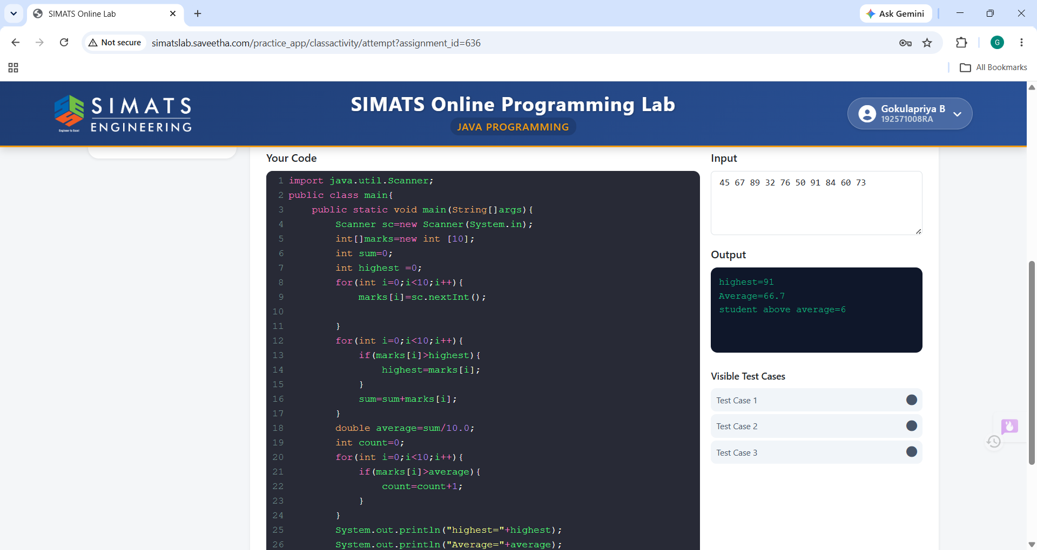

Q2:Attendance Tracker
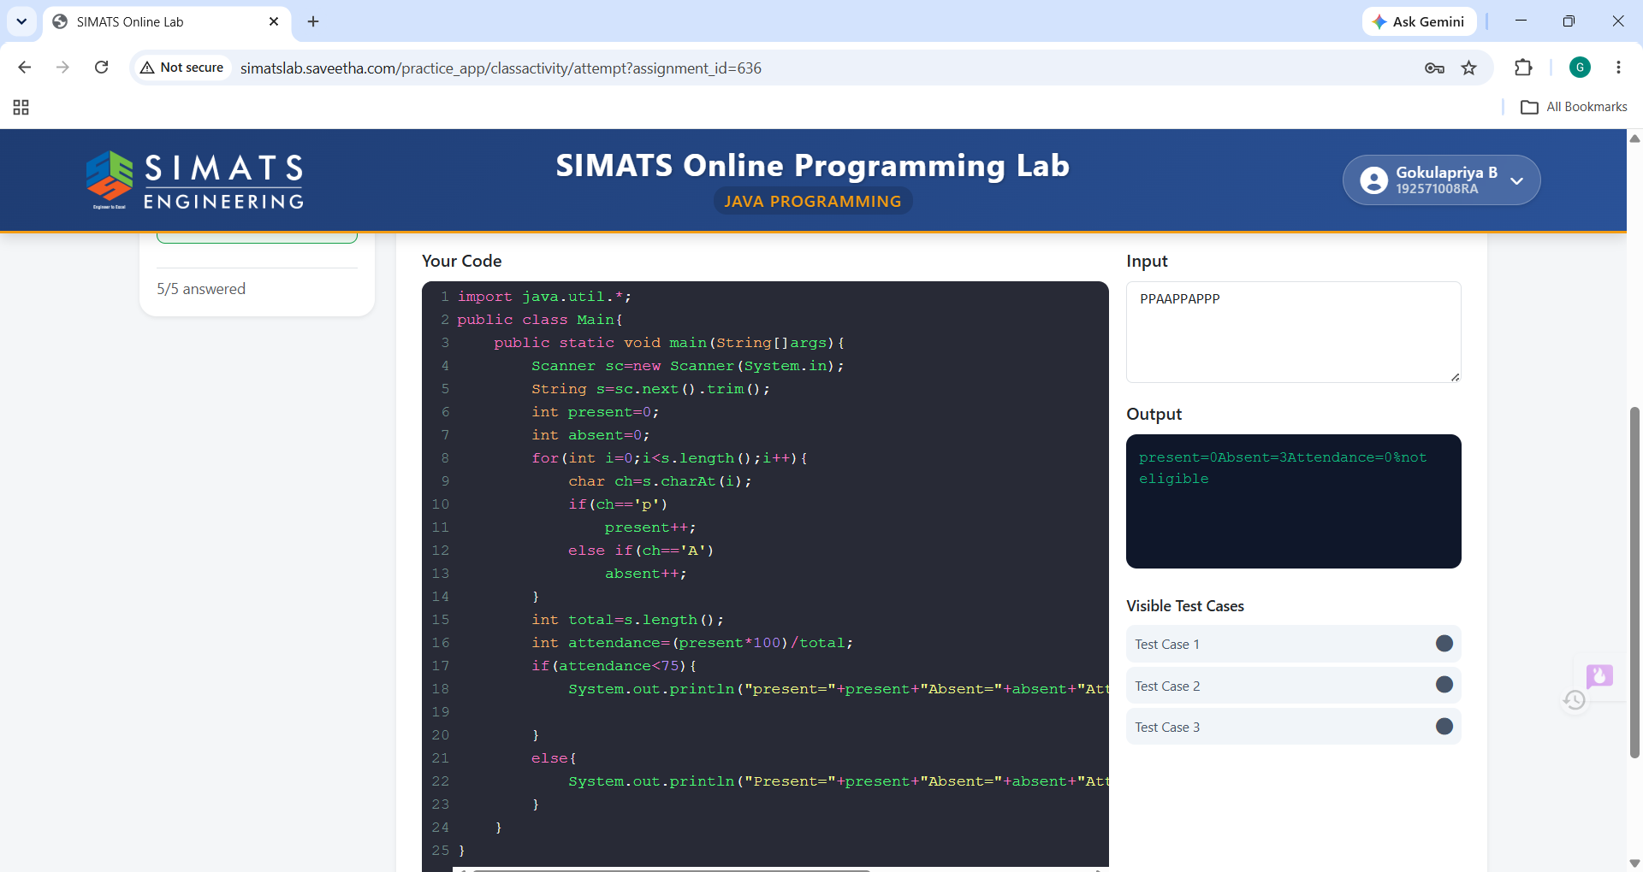

Q3:Exam Result System
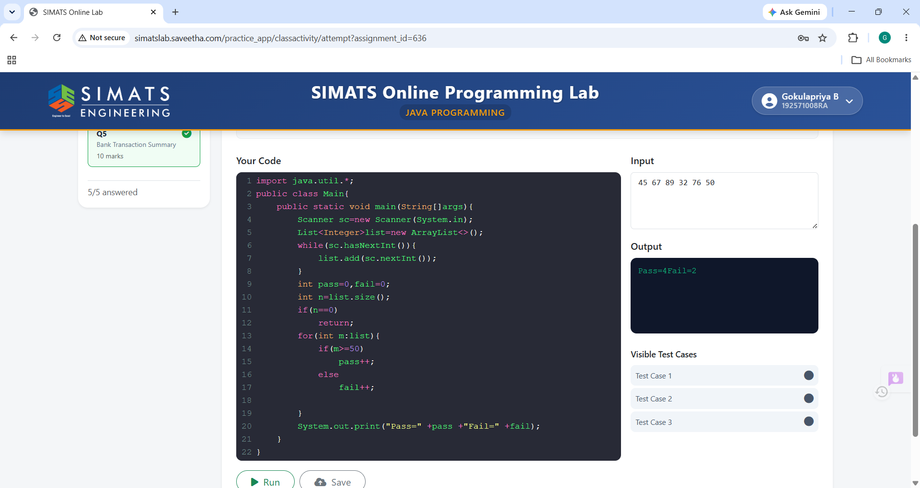

Q4:Duplicates Names Detection
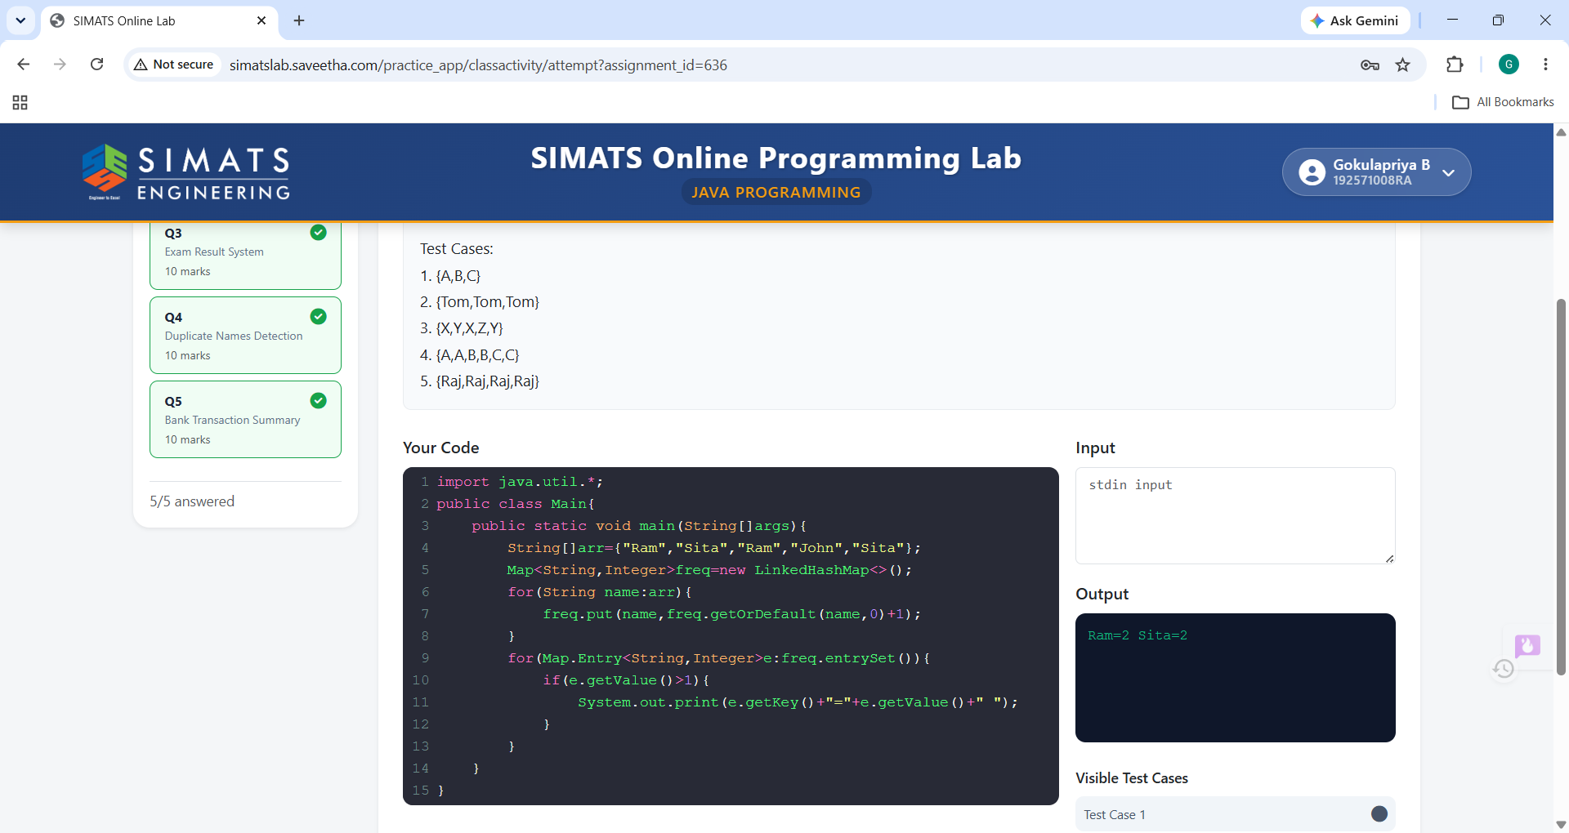

Q5:Bank Transaction Summary
